Naam: …………………

Kijk wat ik al kan: ik reken tussen 10 en 20 !

1. Even herhalen: de splitsingen

6 8 10

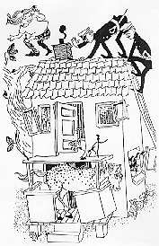
4 4 5
3 7 7
1 3 2
0 1 9

7 9 5

1 2 0
0 4 4
4 6 1
2 0 3

2. Zo doe ik dat.

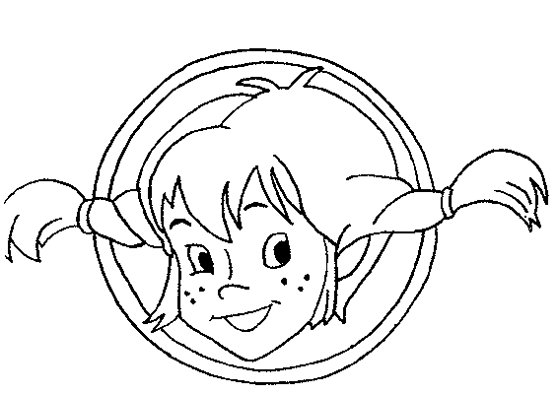
2 + 2 = 5 + 1 = 1 + 9 =

12 + 2 = 15 + 1 = 11 + 9 =

3 + 4 = 4 + 5 = 6 + 4 =

13 + 4 = 14 + 5 = 16 + 4 =

8 – 4 = 3 – 1 = 10 – 3 =

18 – 4 = 13 – 1 = 20 – 3 =

7 – 5 = 5 - 4 = 10 – 6 =

17 – 5 = 15 – 4 = 20 – 6 =

3. Ga zo door!

15 + 2 = 14 + 5 = 12 + 3 = 17 + 3 =

11 + 5 = 13 + 6 = 12 + 8 = 15 + 2 =

13 + 2 = 11 + 2 = 16 + 4 = 14 + 2 =

18 – 1 = 14 – 1 = 20 – 5 = 20 – 2 =

19 – 4 = 15 – 4 = 20 – 7 = 16 – 5 =

17 – 6 = 17 – 6 = 13 – 1 = 17 – 2 =

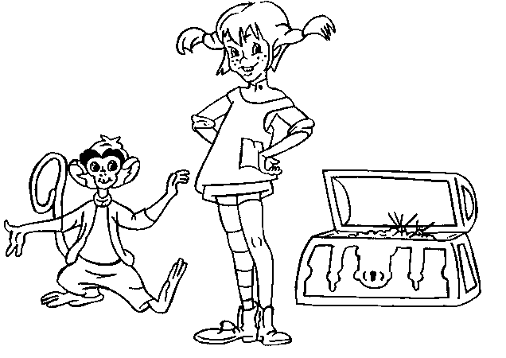
Bron afbeeldingen

http://www.megacoloringpages.com/showtheme.php?theme=pippi%20longstocking

